1.
import java.util.*;
import java.io.*;
public class pgm
{
public static void main(String[] args)
{
Scanner sc=new Scanner(System.in);
double a=sc.nextDouble();
int b=sc.nextInt();
int c=sc.nextInt();
double total;
if(b>40)
{
total=(40*a)+(b-40)*a*1.5;
}
else
{
total=a*b*c;
}
if(b<20)
{
total=total*0.90;
}
double salary=total;
System.out.println(salary);
}
}

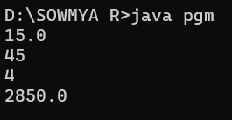
2.
import java.io.*;
import java.util.Scanner;
public class pgm {
public static void main(String[] args) {
Scanner scan = new Scanner(System.in);
String t = scan.nextLine();
int n = scan.nextInt();
double total = 0.0;
switch (t) {
case "Regular":
if (n > 10)
total = n * 50 * 0.90;
else
total = n * 50;
if (total < 200)
total = total +20;
break;
case "VIP":
if (n > 5)
total = n * 100 * 0.85;
else
total = n * 100;
if (total < 200)
total = total +20;

break;
case "Premium":
if (n > 3)
total = n * 150 * 0.80;
else
total = n * 150;
if (total < 200)
total = total +20;
break;
default:
System.out.println("Invalid input");
return;
}
System.out.println(total);
}
}
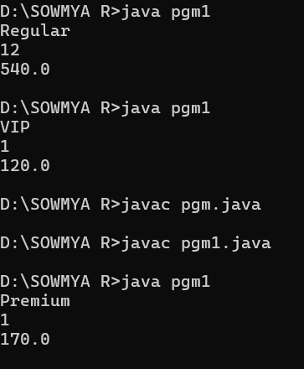
3.
import java.util.Scanner;
public class pgm1 {
public static void main(String[] args) {
Scanner scan = new Scanner(System.in);
int n = scan.nextInt();

int l = Integer.MIN_VALUE;
int s = Integer.MAX_VALUE;

while (n != 0) {
int digit = n % 10;
if (digit > l) {
l = digit;
}
if (digit < s) {
s = digit;
}
n /= 10;
}
System.out.println(s + " " + l);
}
}
